DIETARY STUDY OF COLLEGE STUDENTS

1) GPA – Numerical, actual GPA

2) Gender

1 – Female

2 – Male

3) Breakfast (the participants are shown the following pictures and asked which one of these pictures they associate with the word “breakfast)1 – cereal option and 2 – donut option

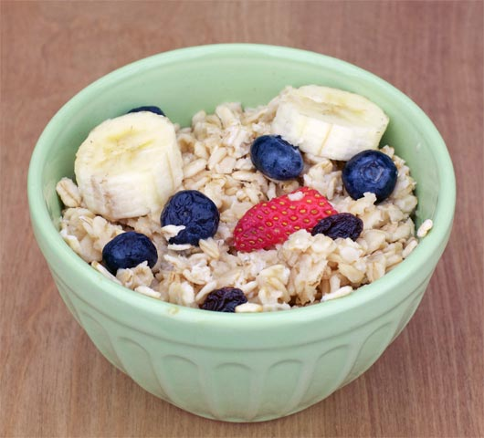 

4) calories_daily_intake

How important is tracking your daily calory intake to you?

1 - Not Important

2 - Moderately Important

3 - Very Important

5) comfort_food_reasons_coded

What makes you reach out for your “Comfort Food”?

1 – stress

2 – boredom

3 – depression/sadness

4 – hunger

5 – laziness

6 – cold weather

7 – happiness

8- watching tv

9 – none

6) cook

How often do you cook for yourself?

1 - Everyday

2 – Occasionally

3 - Not Very Often

4 – Once in a while

5 - Never

7) cuisine

What type of cuisine did you eat growing up?

1 – American

2 – Mexican.Spanish

3 – Korean/Asian

4 – Indian

5 – American inspired international dishes

6 – Other

8) current_diet_coded

How would you describe your current diet?

1 – Healthy

2 – Unhealthy

3 – Monotonous

4 – Unclear

9) diet_changes_coded

How would you describe diet changes after joining college?

1 – Worse

2 – Better

3 – Constant

4 – Unclear

10) eating_out_frequency

How often do you eat out in a typical week?

1 - Never

2 - 1-2 times

3 - 2-3 times

4 - 3-5 times

5 – Everyday

11) employment

Do you work?

1 – Full time

2 - Part time

3 – No

4 - Other

12) exercise

How often do you exercise in a regular week?

1 - Everyday

2 – More than once a week

3 - Once a week

4 - Never

13) fav_cuisine_coded

If available, what cuisine would you prefer?

1. None

1 – Italian/French/greek

2 – Spanish/mexican

3 – Arabic/Turkish

4 – Asian

5 – American

6 – African

7 – Jamaican

8 – Indian

14) fav_food_prep

Was your favorite food cooked at home or store bought?

1 - Cooked at home

2 - Store bought

3 - Both bought at store and cooked at home

15) grade_level

What year are you in?

1 - Freshman

2 -Sophomore

3 - Junior

4 - Senior

16) healthy_feeling

How likely are you to agree with the following statement: “I feel very healthy!”?

1 to 10 where 1 is strongly agree and 10 is strongly disagree - scale

17) Ideal_diet_coded

What would your ideal diet look like?

1 – portion control

2 – adding veggies/eating healthier food/adding fruit

3 – balance

4 – less sugar

5 – home cooked/organic

6 – current diet

7 – more protein

8 – unclear

18) nutritional_check

Do you check nutritional values in products you consume?

1 - never

2 - on certain products only

3 - very rarely

4 - on most products

5 - on everything

19) on_off_campus

What is your living situation?

1 - On campus

2 - Rent out of campus

3 - Live with my parents

4 - Own my own house

20) parents_cook

Approximately how many days a week did your parents cook?

1 - Almost everyday

2 - 2-3 times a week

3 - 1-2 times a week

4 - On holidays only

5 - Never

21) pay_meal_out

How much would you pay for meals out?

1 - <$5.00

2 - $5.01- $10.00

3 - $10.01- $20.00

4 - $20.01- $30.00

5 - $30.01- $40.00

6 - > $40.01

22) self_perception_weight –

What is your self-perception of your weight?

1 – Slim

2 – Very Fit

3 – Just Right

4 – Slightly Overweight

5 - Overweight

6 – N/A

23) vitamins –

Do you take any supplements or vitamins?

1 – Yes

2 – No

24) weight –

What is your weight in pounds?